Lab Manual

Data Communication Networks

BCA324

III

NAME = SUJAL KHUNT

ENROLL = 24FOTCA13902

TUTORIAL 6

Q-1) Explore the use of ping command line utility.

ANS-ping [www.google.com](http://www.google.com/)

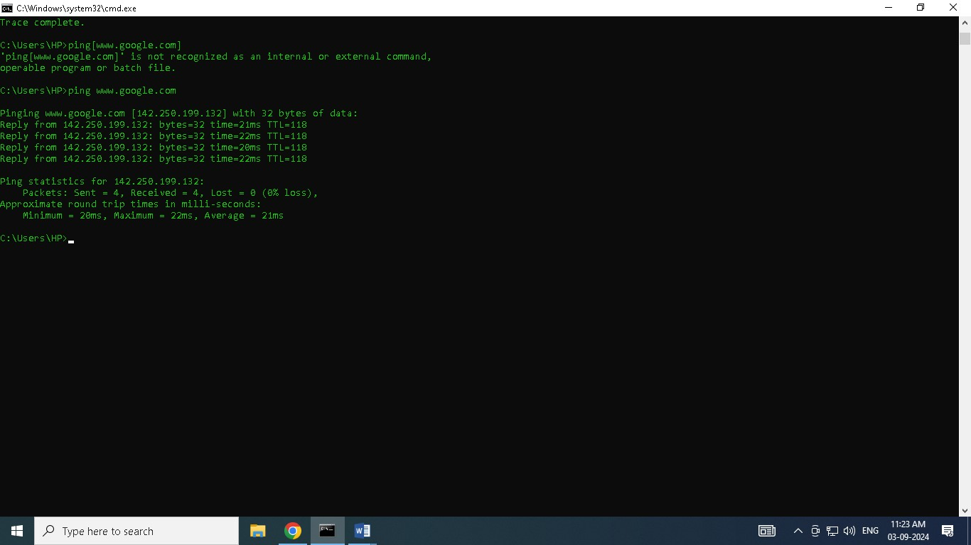

----------------------------------------------------More about ping-----------------------------------------------

The ping command is a command-line utility used to test the reachability of a network device (like a server or website) and to measure the round-trip time it takes for data to travel to that device and back. Here’s a brief overview:

Purpose:

* Check Connectivity: Determine if your computer can reach another device or website over the network.

-Measure Latency: See how long it takes for data to travel to the destination and back.

* Diagnose Network Issues: Identify packet loss or network delays.

Basic Usage:

1. Open Command Prompt:

- Press Win + R, type cmd, and hit Enter.

2. Ping a Host:

* Type the following command and press Enter:

bash ping [hostname or IP address]

* Example: ping www.google.com

3. Understanding the Output:

* Packets Sent/Received: Shows how many data packets were sent and how many were successfully received.
* Round-Trip Time (ms): The time it took for each packet to reach the destination and come back.
* Packet Loss: If some packets don't return, you'll see the percentage of loss, which indicates a network issue.

Common Options:

* ping -t [hostname]: Continuously ping the host until stopped with Ctrl + C.
* ping -n [count] [hostname]: Send a specific number of ping requests (e.g., ping -n 5 www.google.com sends 5 pings).
* ping -l [size] [hostname]: Specify the size of the ping packet in bytes (e.g., ping -l 1000 www.google.com).

Use Cases:

* Check if a website/server is online.
* Measure the speed and stability of your internet connection.
* Troubleshoot network delays or packet loss issues.

The ping command is a simple yet powerful tool for network diagnostics.

